Acknowledgement
The satisfaction that accompanies after the successful completion of any task will be incomplete without mentioning the people whose ceaseless and relentless cooperation, constant guidance and encouragement made this project possible.
We are grateful to our project supervisor Mr. Arpan Pokharel, our faculty teacher Mr. Ramesh Chalise, for the guidance, inspiration and constructive suggestions that helped us in the preparation of this project.
We are also appreciative among each other and have understood that teamwork, the designation of the task per the skillset one portrays, constant synchronization and monitoring of progress and instilling new knowledge and skill is imperative for the success of any given work.
Sincerely,
Generic Thapa
Generic Sharma
Generic Gurung
Generic Nepali

Declaration for
“Project Title”
Student’s Declaration

I (We) hereby declare that I (we) am (are) the only author(s) of this work and that no
sources other than the listed here have been used in this work.

Supervisor’s Declaration

I hereby recommend that this project entitled “Project Title” is done under my
supervision by Student Name1 and Student Name 2 during their _th Semester in
partial fulfilment of the requirements for the degree of Program Name under
Pokhara University is completed to my satisfaction and be processed for final
evaluation.

____________________________
Name of the Supervisor
Date:____ / ____ / ________

Letter of Approval

We certify that we have examined this report entitled “Project Title” and are satisfied
with the project defence. In our opinion it is satisfactory in the scope and qualify as
project in partial fulfilment of the requirements for the degree of Program Name
under Pokhara University.

_____________________
___
Supervisor
Arpan Pokhrel

_____________________
___
Examiner

Date:____ / ____ /

TABLE OF CONTENTS

LIST OF FIGURES

ABBREVIATIONS

Introduction
In recent years, managing and conducting democratic elections or organizational polling has become a major challenge due to rising administrative costs and the vulnerability of traditional paper-based methods. Most small-scale organizations, academic institutions, and local communities rely on manual voting procedures that are labor-intensive, time-consuming, and highly prone to human error. Without a secure and streamlined way to cast and tally ballots, many institutions struggle with delayed results, disputes over accuracy, and a general lack of trust in the electoral outcome.
While there are many enterprise-level digital voting platforms available, most are designed for large-scale government elections and are often too complex or expensive for an organization's daily polling needs. Many of these existing digital solutions are either locked behind costly corporate licensing fees or require complex network infrastructures to manage simple operations. Institutions need a simple, focused, and free tool that helps them conduct secure voting and aggregate data seamlessly without any extra cost.
To address these issues, we will develop "Matpatra" (or your preferred project name), a user-centric digital voting system application using the C programming language. The system will provide a practical, secure, and straightforward environment where administrators can register voters, create candidate lists, and allow users to cast their ballots digitally. By utilizing C programming and robust file-handling techniques, the system will securely store voting records locally, preventing unauthorized tampering and allowing real-time, automated vote calculation.
The main goal of this application is to promote transparency, efficiency, and integrity within localized voting processes. Through localized data storage and strict user authentication controls, the application will eliminate double-voting, minimize human errors in counting, and encourage higher democratic participation. By offering a reliable and cost-effective solution, this system will empower institutions to take control of their electoral processes efficiently and confidently.

Objective
- Automate and Streamline Vote Casting and Counting: To develop a user-friendly, terminal-based C interface that replaces slow manual record-keeping with an efficient digital system. This allows eligible voters to cast their ballots seamlessly while managing fluid databases of local candidates and voter registration details.
- Implement Real-Time, Secure Local Election Monitoring: To leverage local file-handling techniques in C for permanent, tamper-resistant data storage and instantaneous vote tallying without relying on complex, high-cost network setups or cloud utilities. This backend architecture ensures real-time vote consolidation while preventing critical issues like double-voting.
- Provide a High-Accessibility, Distraction-Free Electoral Tool: To deliver a completely cost-free and advertisement-free platform tailored specifically to small-scale community or institutional polling. By eliminating expensive subscription structures and data-privacy risks associated with free online forms, the application ensures a transparent and highly trusted environment for electoral management.
- Ensure Data Integrity and Prevent Fraudulent Polling: To implement validation rules and voter authentication checks within the C backend that prevent common voting discrepancies, such as duplicate voting or unregistered submissions. By structuring a clean, rule-bound logic, the application guarantees that each eligible user gets exactly one vote, preserving the democratic fairness of the election.

Problem statement
- Vulnerability of Manual Ballot Systems: Traditional paper-based voting methods are slow, labor-intensive, and highly prone to human error during counting. Additionally, physical ballots carry a significant risk of being lost, damaged, stolen, or intentionally destroyed.
- Absence of Systematic Audit Trails: Small-scale organizations or academic institutions often lack a secure, structured digital database to track voter participation. Without automated, real-time logging, it is difficult for administrators to verify voter credentials or provide a transparent audit trail in case of disputes.
- Risk of Fraudulent Activity and Double-Voting: Manual verification systems struggle to effectively prevent voter fraud, such as duplicate voting or ballot stuffing, especially when dealing with large or fluctuating voter lists.
- High Costs and Complexity of Existing Platforms: Most enterprise-level electronic voting systems available on the market are designed for large-scale governmental use, making them overly complex and financially unviable for local community, school, or organizational elections.

System design

Use Case Diagram
The Use Case Diagram defines the behavioral boundaries of the application,
illustrating how the primary actor (the Student/User) triggers core operations without
detailing the background storage mechanics.

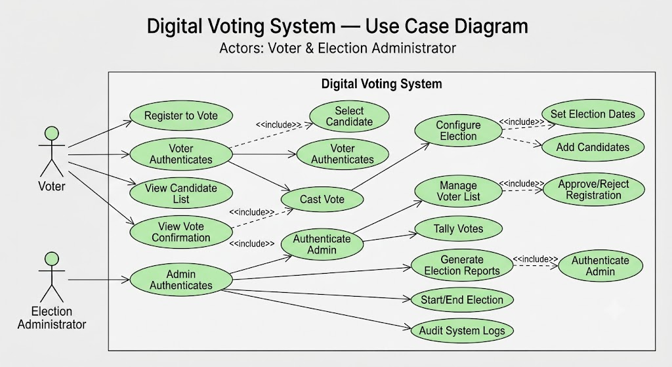

s

